# **Paddock Pal: Drive Through F1 Knowledge**

* Saurabh Vyawahare
* Aniket Patole
* Bhavya Parmar

**1. Introduction**

**Background**

Formula 1 (F1) is renowned for its high-speed action, cutting-edge technology, and a passionate global fan base. However, the sport's intricate nature—spanning evolving regulations, complex race strategies, and detailed driver statistics—makes it challenging for fans and stakeholders to access streamlined, comprehensive information. Despite the massive interest in F1, gaps persist in how accessible and user-friendly this information is, particularly when it comes to understanding rules, track details, driver profiles, and real-time data.

A significant area of concern is the occasional issuance of controversial or incorrect penalties by the FIA, the governing body of Formula 1. These decisions have historically influenced championship outcomes, sometimes resulting in teams or drivers losing crucial points or titles. For instance, during the 2021 Abu Dhabi Grand Prix, contentious decisions sparked widespread debate over the fairness of the championship. Such incidents highlight the need for a solution that enhances transparency, consistency, and accuracy in regulatory decisions.

These challenges and controversies underscore the opportunity to create an innovative platform that educates and supports fans, officials, and even governing bodies like the FIA. This platform would bridge the information gap while fostering a fair and engaging Formula 1 experience.

**Objective**

The objective of this project is to develop **Paddock Pal**, a **Retrieval-Augmented Generation (RAG)**-powered platform designed to revolutionize the Formula 1 experience. Paddock Pal will offer:

1. **Comprehensive F1 Insights**:
   * Easy-to-navigate explanations of regulations.
   * Access to historical data and race details.
   * Driver profiles and track information.
2. **Interactive Engagement**:
   * A predictive game feature for race outcome forecasts, enhancing fan involvement.
3. **Decision-Support for Regulatory Bodies**:
   * Real-time insights into F1 regulations to assist the FIA during critical incidents.
   * Contextual suggestions for penalties based on historical data and predefined rules, promoting fairness and consistency.

For example, in scenarios like a driver forcing another off-track (e.g., "Max Verstappen purposefully pushing Lewis Hamilton off the track"), Paddock Pal can instantly reference relevant regulations and recommend penalties. This functionality ensures accuracy and transparency in race control decisions, thereby fostering trust and fairness in the sport.

Paddock Pal not only addresses the knowledge gap among fans but also acts as a decision-support tool for officials. By integrating technology and innovation, the platform aims to transform the way Formula 1 is experienced, understood, and governed.

**2. Project Overview**

**Scope**

The **Paddock Pal** project is designed to create a multifaceted, interactive platform aimed at transforming how Formula 1 enthusiasts, professionals, and stakeholders interact with the sport. By combining advanced technology, real-time data, and regulatory insights, the platform will provide a centralized hub for both entertainment and decision support. The scope includes:

1. **Data Sources**:
   * Integration of publicly available datasets and APIs like the **OpenF1 API** for live standings and race updates.
   * Real-time synchronization with official regulation documents sourced directly from the **FIA’s website** ([FIA Regulation Library](https://www.fia.com/regulation/category/110)).
   * Analysis of **156 regulatory PDFs** to ensure that every rule and guideline is accessible and easy to understand.
2. **Comprehensive Features**:
   * Offering detailed insights into F1 regulations, race statistics, and driver profiles.
   * Enhancing user engagement with a predictive game module and a chatbot capable of handling complex regulatory and racing-related queries.
   * Providing real-time incident analysis and regulatory support for FIA officials to improve fairness and consistency in decision-making.

**Technologies**

Paddock Pal leverages cutting-edge technologies to deliver a seamless and insightful experience:

1. **Retrieval-Augmented Generation (RAG)**:
   * Used to enhance response accuracy by retrieving relevant regulatory content.
   * Enables the platform to handle intricate queries about F1 regulations, driver statistics, races, and historical data.
2. **Backend**:
   * **FastAPI** for efficient data request handling and backend operations.
   * **Vector databases** like **Pinecone**, combined with OpenAI’s **GPT-4o**, for managing embeddings and generating insightful answers.
3. **Frontend**:
   * Developed using **Streamlit** for an intuitive, interactive user experience.
   * Features dropdown menus, interactive text fields, and a chat-based interface to enhance usability.
4. **Predictive Game Module**:
   * Powered by **Machine Learning models**, this module will offer users the ability to forecast race outcomes based on historical data and predictive algorithms.
5. **Data Automation**:
   * **Airflow** will automate data scraping and ensure the timely update of regulatory documents, race statistics, and real-time data.
6. **Agentic Architecture**:
   * Implements reflection in **Large Language Model (LLM)** agents to ensure response accuracy and reliability.
   * The architecture evaluates and improves LLM outputs through iterative reflection and refinement.

**Reflection in LLMs**

Paddock Pal’s RAG bot incorporates a reflection-based system to optimize the quality of its responses:

1. **Reflection Concept**:
   * The LLM evaluates its past actions, self-reviews generated outputs, and assesses quality based on user interactions.
   * This approach enables re-planning, re-evaluation, and refinement of responses for more accurate outcomes.
2. **LangGraph Integration**:
   * **LangGraph** with **LangChain Fireworks** facilitates seamless LLM interactions, enabling complex query handling.
   * **Tavily** ensures secure and efficient API key management for OpenAI models.
3. **Generate & Reflect**:
   * Generated content undergoes self-evaluation by the LLM, with iterative improvements based on the critique provided.
4. **LangSmith for Debugging**:
   * LangSmith uses trace data to debug and enhance LLM performance, ensuring accurate and reliable answers for F1 regulations and race data queries.

**Expected Deliverables**

The final deliverables for the Paddock Pal project include:

1. **Web-Based Platform**:
   * A centralized hub with three core modules:
     1. **Information Hub** for educational content and regulatory insights.
     2. **Comprehensive RAG Bot** integrated with APIs to provide chatbot-driven race and regulation information.
     3. **Predictive Game Module** to boost user engagement.
2. **Real-Time Data Integration**:
   * Live updates on race standings, driver stats, and incidents.
   * Immediate regulatory analysis during on-track events.
3. **User-Friendly Interface**:
   * Seamless navigation across modules, with an emphasis on usability for fans, officials, and professionals.

**Stakeholders**

**1. Primary End Users:**

* **Formula 1 Fans & FIA Officials**:
  + Fans will benefit from easily digestible information on races, drivers, and regulations.
  + FIA officials can use the platform as a decision-support tool to assess regulations in real-time, ensuring fair penalties and consistent decision-making.

**2. Teams & Drivers:**

* Teams and drivers will have quick access to regulatory precedents, race data, and predictions, aiding strategy formulation during race weekends.

**3. Content Creators & Journalists:**

* Individuals producing F1-related content can rely on the platform for reliable historical data, regulation clarifications, and real-time updates, enhancing the quality of their work.

**Financial Considerations**

The popularity of Formula 1 presents a lucrative market opportunity:

* In Q1 2024, F1 generated **$871 million in revenue**, reflecting a **20% increase** from 2023’s **$724 million**.
* Paddock Pal’s ability to attract F1 fans, professionals, and stakeholders can contribute to this growing ecosystem, offering potential avenues for monetization through premium features, advertising, or partnerships.

**3. Problem Statement**

**Current Challenges**

The Formula 1 ecosystem, while technologically advanced and globally popular, faces significant challenges related to data access, usability, and decision-making. These challenges impact various stakeholders, from fans to officials and even the FIA itself. The following are key issues currently plaguing the landscape:

**1. Accessibility of Regulations**

* **Complexity of Documents**: Official FIA regulation documents are intricate and densely written, making them difficult to understand for casual fans and even seasoned professionals.
* **Limited Usability**: During live races or high-pressure scenarios, officials and teams struggle to locate and interpret the relevant regulations quickly. This can result in delayed or incorrect decisions that may affect race outcomes.

**2. Fragmented Data Management**

* **Disparate Sources**: Historical data, real-time race analytics, and regulatory documents are stored across multiple platforms with no centralized access. This fragmentation complicates the process of gathering and synthesizing relevant information.
* **Manual Efforts**: Teams, journalists, and fans often have to piece together data manually, which is both time-consuming and prone to errors.

**3. Lack of Interactive Decision-Support Tools**

* **Inconsistent Penalty Decisions**: The absence of AI-powered decision-support tools means that penalties during incidents are sometimes inconsistent. For example, similar incidents involving aggressive driving may result in different outcomes depending on the stewards’ interpretation, undermining the sport's credibility.
* **Reactive Approach**: Current systems are largely reactive, with little emphasis on proactive insights or predictive analytics that could enhance race strategies and decision-making.

**4. Challenges in Fan Engagement**

* **Steep Learning Curve**: New or casual fans find it difficult to grasp the complexities of F1, from understanding race strategies to decoding technical regulations.
* **Limited Interactivity**: Existing platforms do not offer engaging ways to explore F1 data, which reduces fan interaction and retention.

**Opportunities**

The **Paddock Pal** project offers a transformative opportunity to address these challenges comprehensively by leveraging modern AI and data management technologies. Here’s how:

**1. Centralized Data Access**

* **Unified Platform**: By integrating historical data, real-time updates, and regulation documents into a single platform, Paddock Pal will eliminate the need for users to navigate multiple resources.
* **Ease of Navigation**: An intuitive interface will enable fans, journalists, and professionals to search and access information seamlessly, improving overall usability.

**2. RAG-Powered Regulation Bot**

* **Enhanced Decision-Making**: The Retrieval-Augmented Generation (RAG) bot can provide real-time, context-specific insights into FIA regulations, enabling the FIA and stewards to make consistent and fair decisions during races.
* **Reducing Controversy**: By ensuring accurate interpretation of rules, the platform minimizes controversial decisions that can negatively impact championship standings and the sport’s reputation.

**3. Interactive Fan Engagement**

* **Predictive Analytics**: Integrating predictive tools into the platform will allow fans to engage with the sport in new and exciting ways, such as forecasting race outcomes and comparing their predictions to real results.
* **Education Through Interactivity**: Interactive features like quizzes, gamified learning, and detailed race breakdowns will educate fans on the intricacies of F1 strategies and regulations, fostering a deeper connection to the sport.

**4. Decision-Support for FIA Officials**

* **Real-Time Regulation Lookup**: During live incidents, the system can quickly retrieve and highlight relevant regulations, ensuring timely and fair decisions.
* **Precedent Analysis**: The platform can reference historical penalties and decisions for similar incidents, providing context and promoting consistency in stewarding.

**5. Transparency and Trust**

* **Clear Communication**: By making regulatory decisions more transparent and data-driven, the platform enhances trust between the FIA and fans, addressing skepticism caused by past controversies.
* **Engaged Stakeholders**: Teams, drivers, and journalists will have access to reliable, centralized information, improving their ability to analyze and communicate race events.

**Benefits for Stakeholders**

1. **Fans**:
   * Gain access to easy-to-understand explanations of F1 regulations and race analytics.
   * Enjoy interactive tools that deepen their engagement and enhance their understanding of the sport.
2. **FIA and Officials**:
   * Leverage AI-driven insights to ensure fair, consistent, and transparent regulatory decisions during races.
   * Improve credibility by reducing controversy in penalties and rulings.
3. **Teams and Drivers**:
   * Utilize centralized data and predictive analytics to optimize race strategies and incident management.
4. **Content Creators and Journalists**:
   * Streamline content creation with quick access to reliable data and regulatory clarifications.

**4. Architecture Diagram**

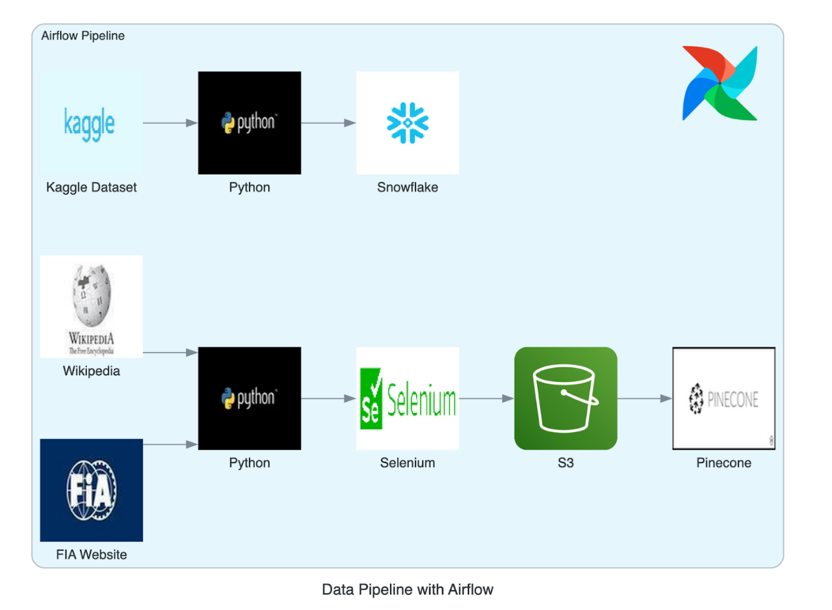

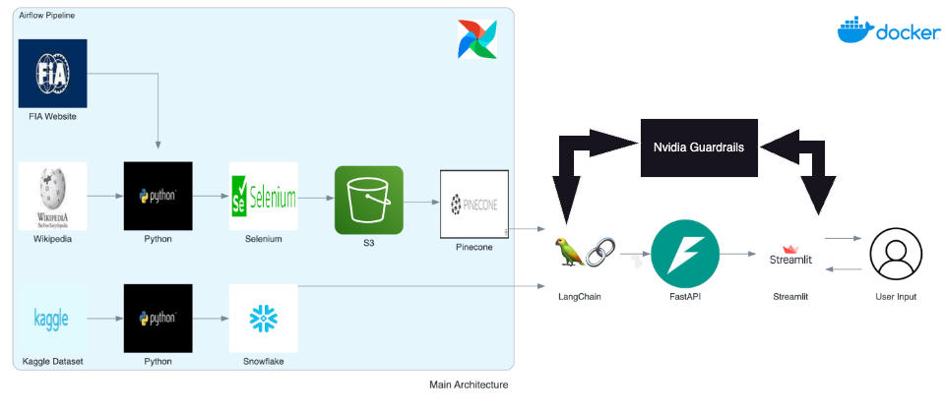

**5. Methodology**

The **Paddock Pal** project leverages a combination of advanced technologies, APIs, and data processing tools to create a robust and interactive Formula 1 platform. The methodology ensures comprehensive data coverage, seamless integration of components, and efficient processing of both structured and unstructured data. Below is a detailed breakdown of the methodology:

**Data Sources**

To ensure accurate and comprehensive coverage of Formula 1 regulations, race results, track details, and driver statistics, **Paddock Pal** will utilize multiple data sources:

**1. Official FIA Regulation Documents**

* **Source**: FIA regulation documents will be scraped directly from the official Formula 1 website ([FIA Regulation Library](https://www.fia.com/regulation/category/110)).
* **Storage**: These documents will be stored in **Amazon S3** for centralized access.
* **Text Extraction**: Text from PDFs will be extracted using **Adobe Extractor**, ensuring a structured and machine-readable format for downstream analysis.

**2. OpenF1 API**

* **Purpose**: Provides real-time race data, live standings, driver statistics, and historical race results.
* **Integration**: Enables continuous updates to ensure the platform remains dynamic and relevant during live races.

**3. Scraped Data**

* **Tools Used**: Web scraping tools like **BeautifulSoup** (for static content) and **Selenium** (for dynamic content) will be employed to scrape regulation PDFs and other relevant data from Formula 1 websites.
* **Automation**: Scraping workflows will be automated using **Airflow**, ensuring that updates occur regularly and with minimal manual intervention.

**4. Custom Synthesized Data**

* **Purpose**: Historical race incidents and their corresponding penalties will be synthesized into a database to create a robust repository of example cases.
* **Usage**: This data will enrich the RAG system, enabling it to provide contextual and precedent-based penalty recommendations.

**Technologies and Tools**

**1. Backend & Data Access**

* **FastAPI**:
  + Manages backend services, including API requests and integration with data sources.
  + Ensures fast, asynchronous handling of user queries.
* **Snowflake**:
  + Serves as the primary database for storing structured data such as regulation clauses and historical race information.
  + Provides scalability, security, and efficient querying.
* **Pinecone**:
  + A vector database used to store embeddings of regulatory text.
  + Enables fast and accurate retrieval of relevant clauses for RAG-based responses.

**2. Data Processing & AI**

* **OpenAI’s ChatGPT-4**:
  + Powers the **Retrieval-Augmented Generation (RAG)** module to answer regulation-related questions, interpret race data, and provide intelligent insights.
* **Scikit-Learn (Sklearn)**:
  + Used for predictive modeling, enabling race outcome predictions based on historical data and user inputs.

**3. Frontend Development**

* **Streamlit**:
  + Provides a clean, interactive interface for end users.
  + Features dropdown menus, text fields, and a chat-like UI for querying regulations, accessing race data, and engaging with the predictive game module.

**4. Data Extraction & Processing**

* **Adobe Extractor**:
  + Handles text extraction from official FIA PDFs, ensuring structured outputs for regulation analysis.
* **BeautifulSoup & Selenium**:
  + BeautifulSoup processes static content, while Selenium handles dynamic elements for scraping.
* **Airflow**:
  + Orchestrates and schedules scraping workflows, ensuring regular and efficient data ingestion.

**Data Pipeline Design**

The Paddock Pal data pipeline ensures efficient ingestion, transformation, and storage of both structured and unstructured data. The pipeline consists of the following stages:

**1. Data Ingestion**

* **API Data**: Real-time data, such as standings and results, will be fetched from APIs like **OpenF1**.
* **Scraping & Extraction**:
  + Regulation PDFs will be scraped from the FIA website using **BeautifulSoup** and **Selenium**.
  + **Airflow** will automate the orchestration of these scraping tasks.
  + Extracted PDFs will be stored in **Amazon S3**, and their text will be processed using **Adobe Extractor**.

**2. Data Transformation**

* **Text Processing**: Extracted regulatory text will be divided into searchable chunks for efficient embedding generation.
* **Storing Structured Data**:
  + Structured data, such as indexed regulation content, will be stored in **Snowflake** for easy access and analysis.

**3. Data Storage**

* **Snowflake**: Stores structured data (e.g., regulations and historical race data) for efficient querying.
* **Pinecone**: Hosts embeddings of regulatory text, enabling fast retrieval for RAG-based queries.
* **Amazon S3**: Serves as the repository for unstructured data, such as the scraped FIA PDFs.

**Data Processing and Transformation**

**1. Embedding Generation**

* **Tool**: OpenAI’s Embedding API.
* **Purpose**: Generate vector embeddings for regulatory clauses to facilitate efficient retrieval in the RAG module.

**2. Retrieval-Augmented Generation (RAG) System**

* **Process**:
  + User queries are matched with relevant regulatory embeddings in **Pinecone**.
  + The system fetches the most relevant clauses and uses **ChatGPT-4** to generate comprehensive, context-aware responses.

**Tools for Tracking and Development**

**1. Airflow**

* Manages and automates all data scraping and ingestion workflows.
* Ensures that regulation documents, race data, and other information are consistently updated without manual intervention.

**2. LangChain and Pinecone Integration**

* Enables seamless connection between embedding storage and the RAG system, ensuring fast, accurate responses to user queries.

**Advantages of the Methodology**

**1. Efficiency and Automation**

* Regular updates and automation of data ingestion through **Airflow** minimize manual labor and ensure up-to-date information.

**2. Scalability**

* Use of scalable tools like **Snowflake** and **Pinecone** ensures the platform can handle increasing amounts of data and queries as the user base grows.

**3. Reliability**

* Integration of **Adobe Extractor**, **FastAPI**, and robust AI models ensures accurate data extraction, processing, and response generation.

**4. User-Centric Design**

* The combination of **Streamlit’s interactive frontend** and **ChatGPT-4’s natural language capabilities** provides a seamless and intuitive user experience.

**5. Risks and Mitigation Strategies**

**Identified Risks**

The **Paddock Pal** project, while innovative, presents several potential risks due to its tight timeline and complex architecture. Below is an overview of key risks and their potential impacts:

**1. Time Constraint Risk**

* **Description**: With only three weeks to complete the project, the ambitious goals of integrating multiple components (RAG Bot, Information Hub, predictive game, etc.) may lead to delays or incomplete implementation.
* **Impact**: Delayed feature completion could result in an incomplete or non-functional product.

**2. Data Integration Challenges**

* **Description**: Combining data from diverse sources (Snowflake, Pinecone, OpenF1 API) poses challenges in aligning formats and ensuring consistency.
* **Impact**: Misaligned data or integration issues could cause delays and errors in backend processes, reducing system reliability.

**3. API Reliability**

* **Description**: The OpenF1 API, a critical source of real-time data, could experience outages, rate-limit restrictions, or delays in data delivery.
* **Impact**: Interruptions in real-time data flow could degrade user experience, especially during live events.

**4. Backend and Frontend Sync Issues**

* **Description**: Ensuring seamless communication between the backend (FastAPI) and frontend (Streamlit) might be challenging, particularly with real-time data updates.
* **Impact**: Any miscommunication between components could lead to system crashes or unresponsive features.

**5. Data Quality and Availability**

* **Description**: Extracting high-quality, structured data from PDFs and scraped documents is complex. Missing or incomplete data may compromise the accuracy of the RAG bot and predictive features.
* **Impact**: Poor data quality could reduce user trust in the platform and its insights.

**6. Limited Testing Window**

* **Description**: The short timeline may limit the amount of testing, leaving bugs and performance issues undetected until after deployment.
* **Impact**: Post-deployment issues could harm the platform’s usability and credibility.

**Mitigation Strategies**

To address these risks effectively, the following mitigation strategies have been devised:

**1. Mitigating Time Constraints**

* **Prioritize Core Features**: Focus on delivering essential features first, including the RAG Bot, Information Hub, and backend integration. Non-critical features, such as additional enhancements, can be added in later iterations.
* **Parallel Development**: Assign specific responsibilities to each team member:
  + **Saurabh**: Backend and API integration.
  + **Aniket**: Data integration and processing.
  + **Shreya**: Frontend development.
  + This division of work ensures maximum productivity and parallel progress.

**2. Addressing Data Integration Challenges**

* **Standardized Data Formats**:
  + Define a common data format for all sources to ensure compatibility with Snowflake, Pinecone, and APIs.
  + Use data validation steps during preprocessing to catch inconsistencies early.
* **Incremental Integration Testing**:
  + Integrate data sources one at a time.
  + Perform regular testing after each integration stage to identify and address issues early.

**3. Ensuring API Reliability**

* **Backup Data Sources**:
  + Store historical data in **Snowflake** as a fallback for the OpenF1 API. This cached data can ensure the chatbot remains functional during API outages.
* **API Usage Monitoring**:
  + Implement rate-limiting and monitoring mechanisms to track API usage and prevent exceeding quotas.
  + Plan fallback modes where the system can temporarily rely on stored or synthesized data if API limits are reached.

**4. Synchronizing Backend and Frontend**

* **Frequent Sync Tests**:
  + Conduct regular tests to validate data transfer between FastAPI and Streamlit during development.
  + Simulate real-time data updates to ensure smooth communication between components.
* **Error Logging**:
  + Implement logging mechanisms on both the frontend and backend to detect and resolve issues quickly.
  + Use clear and detailed error messages to streamline debugging efforts.

**5. Improving Data Quality and Availability**

* **Manual Verification**:
  + Perform manual reviews of scraped data and Adobe Extractor outputs to ensure completeness and accuracy.
  + Prioritize critical data points for review to save time without compromising quality.
* **Fallback Responses**:
  + Design fallback mechanisms for the RAG bot, allowing it to provide alternate answers or indicate unavailable data when gaps exist.
  + This ensures that users still receive helpful responses even with incomplete datasets.

**6. Maximizing the Testing Window**

* **Unit Testing**:
  + Each team member will thoroughly test their individual components before integration.
  + This minimizes the risk of critical bugs arising during system-wide testing.
* **User Acceptance Testing (UAT)**:
  + Dedicate the final days of the timeline to focused user testing.
  + Gather feedback to identify and resolve major usability or functionality issues.
* **Bug Prioritization**:
  + Classify bugs into severity categories (e.g., critical, high, medium, low).
  + Address critical issues first to ensure the core functionality of the platform is stable.

**7. Conclusion**

**Paddock Pal** is envisioned as a transformative platform tailored to meet the diverse needs of Formula 1 fans, professionals, and governing bodies. By addressing key challenges in data accessibility, user engagement, and decision-making fairness, it aims to redefine how stakeholders interact with the sport. The integration of cutting-edge technologies, such as **Retrieval-Augmented Generation (RAG)** for regulation-based queries, real-time data feeds via the **OpenF1 API**, and an engaging **predictive game component**, highlights the platform's commitment to innovation.

**Core Objectives and Deliverables**

Paddock Pal’s strength lies in its multifaceted approach:

1. **Enhancing Accessibility**:
   * By providing seamless access to regulations, track details, and driver statistics through an intuitive interface, the platform empowers users to navigate the complexities of Formula 1 effortlessly.
2. **Engaging Fans**:
   * Interactive features, like the predictive game, transform learning about race dynamics and strategies into an entertaining experience, appealing to both casual viewers and dedicated enthusiasts.
3. **Supporting Fair Decision-Making**:
   * With its RAG-driven regulatory insights, Paddock Pal assists FIA officials in making consistent, data-driven decisions during high-pressure incidents, reducing controversies and increasing trust in the sport's governance.

**Impact and Value Proposition**

The platform combines **educational**, **entertaining**, and **informative** elements, setting it apart as a holistic resource for the Formula 1 community. Its anticipated benefits include:

* **For Fans**:
  + Deeper engagement with the sport through interactive tools, real-time data, and insights into race dynamics.
* **For Professionals**:
  + Streamlined access to historical data, regulations, and precedents, enabling teams and journalists to enhance their analyses and reporting.
* **For the FIA**:
  + Real-time decision-support tools that provide instant access to relevant regulations, ensuring fair and transparent outcomes.

By prioritizing these aspects, Paddock Pal is poised to fill critical gaps in the current Formula 1 ecosystem.

**Development Strategy**

Despite the tight three-week development timeline, the focus is on delivering a **Minimum Viable Product (MVP)** that achieves the following:

* **Core Features**:
  + Fully functional RAG bot for regulation queries.
  + A user-friendly information hub for track, driver, and race data.
  + Predictive analytics integrated into the game module.
* **Scalability**:
  + The platform’s modular design will allow for iterative enhancements and future expansion.
* **Measurable Outcomes**:
  + **Prediction Accuracy**: Quantifying the effectiveness of the predictive game.
  + **User Engagement Metrics**: Tracking interactions with the platform to evaluate its usability and appeal.
  + **API Performance**: Ensuring reliability and seamless integration of data sources like OpenF1 and Snowflake.

**Broader Implications and Opportunities**

The success of Paddock Pal could pave the way for:

* **Expansion into Other Motorsports**:
  + The platform’s architecture is adaptable, enabling future applications in other racing domains such as MotoGP, Formula E, or NASCAR.
* **Advanced Analytics**:
  + Incorporating more sophisticated machine learning models and real-time analytics for deeper insights into race strategies and team performance.
* **Commercial Opportunities**:
  + Collaborations with F1 teams, content creators, and broadcasters for exclusive features or premium services.

By fostering greater transparency, improving decision-making, and elevating user engagement, Paddock Pal has the potential to become an indispensable tool in the world of motorsport.

**Final Thoughts**

With a clear vision, well-defined goals, and a dedicated team, Paddock Pal is on track to deliver a unique and impactful product. It promises to revolutionize the Formula 1 experience by making it more transparent, engaging, and accessible. The combination of advanced AI, comprehensive data integration, and user-focused design positions Paddock Pal as a trailblazer in the intersection of sports and technology.

As the project progresses, feedback from the Formula 1 community will further refine its features, ensuring a robust and versatile platform that meets the evolving demands of fans, professionals, and governing bodies alike.

**References**

1. [Formula 1 Revenue Increase Report](https://www.si.com/fannation/racing/f1briefings/news/f1-reports-huge-revenue-increase-as-revenue-revealed-01j4szmv11p7#:~:text=Formula%20One%20Group%20has%20reported,the%20corresponding%20quarter%20of%202023.)
2. [FIA Regulation Documents](https://www.fia.com/)